**Password Generator**

**Objective :-**

The idea behind password originators is noble. We are in a modern technological era where almost everyone has various high-tech gadgets. The sophisticated devices are used in connecting and sharing information with other computing devices. At times they connect with banks and help in completing financial transactions. As such, they’re prone to unauthorized access that may lead to loss of valuable data or money. Furthermore, unauthorized users may use your logins to commit a cybercrime leaving you in trouble with the authorities.

The most prevalent way hackers can break through computers is by guessing your password. Use of simple and common passwords creates an opportunity for hackers to get access to your electronic devices. Since no one would wish to have their personal information stolen, [use strong passwords](https://www.teampassword.com/blog/tips-and-tricks-to-create-a-strong-password) to protect your information. Thanks to the “Password Generator”.

When we sign-in to our account of any website, then we enter a specific password, that specific password is may be strong or may be not strong. And if the password is not strong then the hackers steel the confidential data from your account. That’s why we provide a webpage for you to generate strong password randomly from webpage and if you like a password, then just copy that password and change the account old password with this new password.

**Scope of the Project :-**

Today’s mostly fields are covered with IT field, so many things are confidential. Thus this project is used for generating a strong and well-defined password. The scope of this project gives safety and security in all the IT related things. Like Meta, Google Accounts, LinkedIn, Cloud Apps, Physical Lockers and etc.

**Methodology :-**

In this we use the HTML, CSS and JavaScript language.

**In JavaScript :-**

***For Random Password Generator :-***

We use array of Lowercase characters, Uppercase characters, Numbers and Symbols.

***For MD5 Password Generator :-***

We use these JS -

<https://cdnjs.cloudflare.com/ajax/libs/crypto-js/4.0.0/core.min.js> and <https://cdnjs.cloudflare.com/ajax/libs/crypto-js/3.1.9-1/md5.js>

to generate MD5 password.

**Gantt Chart :-**

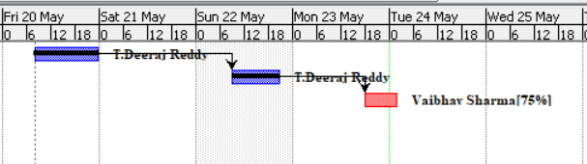

**References :-**

<https://stackoverflow.com/questions/51803137/how-do-i-output-a-string-from-a-textbox-in-javascript>

<https://www.studytonight.com/post/building-a-password-generator-with-javascript>

<https://stackoverflow.com/questions/14733374/how-to-generate-an-md5-file-hash-in-javascript-node-js>

<https://www.sourcecodeexamples.net/2020/09/javascript-project-password-generator.html>

<https://cdnjs.cloudflare.com/ajax/libs/crypto-js/4.0.0/core.min.js>

<https://cdnjs.cloudflare.com/ajax/libs/crypto-js/3.1.9-1/md5.js>